Appalachian State University Airless Tire Testing Report
For Electric Bikes

Don J. Gerhardt PhD, PE
John H. Martin, EdD

June 12, 2020

Executive Summary
Appalachian State University (ASU) Students in the Electric Bike Technology Course tested airless tires for electric bike applications. This research was supported by a grant from Amerityre Corporation and support from the non profit Electric Auto Association – Triad Electric Vehicle Association Chapter (EAA-TEVA).
The class was taught by Dr. John H. Martin with support from Dr. Don J. Gerhardt and members of EAA-TEVA. Thirteen students and seven EAA-TEVA members participated with the testing.
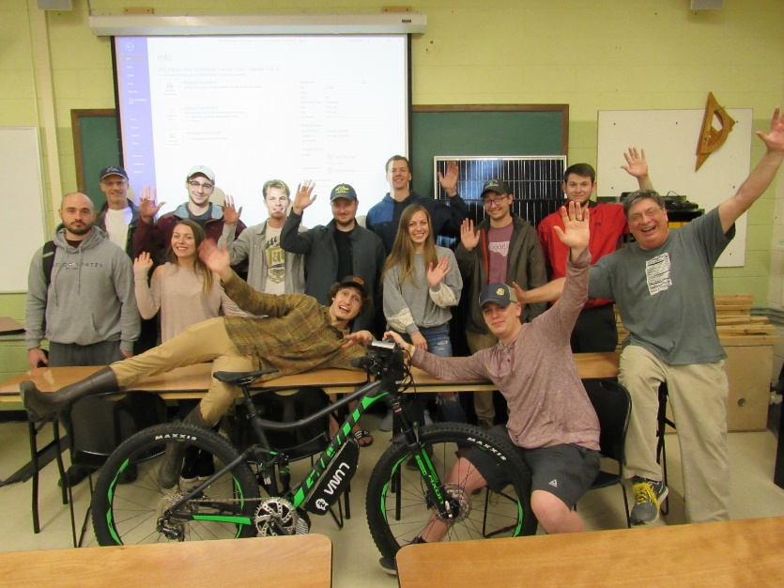
Appalachian State University (ASU) Students in the 2020 Electric Bike Technology Course
The testers completed 358 tests with 2 special test bikes. The airless tires performed better than expected. The airless tires are similar to air tires for casual riders. Recommendations are made for improvements for advanced riders and suggested next steps.

Contents
- Executive Summary
- Table of Contents
- Introduction
- Results Summary
- Recommendations
- Appalachian State University (ASU)
- Electric Bike Maintenance Manual (EBMM)
- ASU TEVA Tire Test Data and Information USB Drive
- Test E-Bikes
- Test Facilities
- Test Types
- Trailer Test
- Test Data
- Wheels

3. Introduction
There are approximately 200 million E-Bikes in service worldwide. Annual worldwide sales are approximately 36 million units. There are over 500 manufacturers of E-Bikes. The major brands are listed in Appendix A11 of the Electric Bike Maintenance Manual (EBMM) ISBN 978-0-9905228-0-5 by Don J. Gerhardt.
The main E-Bike/LEV organization for manufacturers and dealers is the Light Electric Vehicle Association (LEVA). The web site is www.levassociation.com. The long term plan is to develop a LEVA test standard for airless tires for E-Bikes. The test standard would eventually become an ISO standard after a preliminary evaluation period.
There are many types of E-Bikes. Some of the types include:
- Cargo
- Child
- Commuting
- Delivery
- Dutch Style City Models
- Folding
- Gravel
- Hybrid
- Mountain
- Police
- Powered Trailer
- Racing
- Road
- Recreational
- Recumbent
- Rental
- SUV E-Bike
- Treking
- Trikes
- Work
Mountain E-Bikes can be further classified as Light, Medium, Heavy Duty or Downhill. The motor on a Downhill bike is used to get the bike up the hill.
4. Results Summary
Two Test E-Bikes were built with Cycle Analyst Data Logger data acquisition systems.
- Giant Mountain E-Bike with Bafang mid drive motor
- Sun Drifter E-Bike with Cyclone mid drive motor
186 tests were conducted with the Giant E-Bike and 172 tests were conducted with the Sun E-Bike. The raw data for the 358 total tests are provided in the “A1 Data Folder” of the ASU TEVA Tire Test Data and Information USB Drive. Data Index Summary Excel spreadsheets for both test bikes are also located in the “A1 Data Folder”. The tests were conducted by 20 different riders from ASU and EAA-TEVA. The skill level of the riders ranged from casual to advanced.
43 Trip Analyzer Reports have been written. These reports are in the “Trip Analyzer Reports” folder of the ASU TEVA Tire Test Data and Information USB Drive.
The most significant results include the following:
- Lugs came off the 26 inch mountain bike tire on the test mountain E-Bike and the 20 inch mountain bike tire on a trailer.
- The casual rider will not notice a significant difference between the performance of the airless tire and the air type tire of the same size.
- The advanced rider noticed a difference in ride quality and handling performance of the airless tire and the air type tire of the same size. The difference depends on the expectation of the rider. Advanced riders notice a “squirm” with the airless tires during handling tests.
- Advance mountain bike riders who have used the latest high technology wider mountain bike tires will not be satisfied with the older narrow airless mountain bike tires.
- It was difficult to find standard rims that would fit the airless tires.
- It was difficult to install the airless tires on rims with a tight fit. It was easy to install the airless tires on rims with a looser fit. The tires with the looser fit worked fine. They did not come off the rim or slip on the rim with heavy braking or acceleration with high torque.
- Braking was good. However flat spots were generated on the tires when the brakes were locked up. This is considered to be abusive operation. We were able to safely continue to use the tires with flat spots. Future high performance E-Bikes will be equipped with anti-skid brakes.
- We failed a wheel during aggressive testing on a mountain bike trail. The Ameritye mountain bike tire was not damaged during the wheel failure other than missing lugs.

5. Recommendations
- Lugs came off the 26 in mountain bike tire on the test mountain E-Bike and the 20 mountain bike tire on a trailer. The root cause of the failures need to be determined and corrected to protect the reputation of Amerityre.
- Voice of the Customer – Quality Function Development (QFD-QFD) customer surveys should be done to determine customer “Wants” and Target Costs for the tires.
- A simple installation device should be developed to reduce the time to install the tires on wheels.
- Relationships should be developed with key E-Bike manufacturers to apply airless tires.
- The best initial applications for airless E-Bike tires are probably with cargo, commuting, delivery, trailers, recreational, rental and work vehicles.
6. Appalachian State University (ASU)
ASU specializes in environmentally friendly education. It is the first University in the world to offer a course on E-Bike Technology. The course is certified by the Light Electric Vehicle Association. ASU has given full support for test track facilities for testing E-Bikes and components.
7. Electric Bike Maintenance Manual
The Electric Bike Maintenance Manual (EBMM) ISBN 978-0-0005228-05 by Don J. Gerhardt contains information on the design, test and maintenance of E-Bikes. A USB card of the EBMM is provided as part of this report. The EBMM is the text book used for the ASU LEVA course.
8. ASU TEVA Tire Test Data and Information USB Drive
An ASU TEVA USB drive was given to Each student with information and a place to store their data. The USB drive contains the following folders. An ASU TEVA USB drive with all the data and reports is provided as part of this report
- A1 Data Folder
- A2 Student Reports Folder
- Class Agendas
- Gerhardt Cycles Reports
- Information and Procedures
- Trip Analyzer Reports
- Wheel and Tire Build Documents
- ASU Amerityre Airless Tire Report

9. Test E-Bikes
Two special E-Bikes were custom build for airless tire testing. Both E-Bikes have programable high torque mid drive electric motors. The mid-drive motors allow rapid change of prebuilt wheels and tires compared to hub motors
The Giant mountain E-Bike has a special Bafang motor with hydraulic disk brakes. The Sun Drifter E-Bike has a special Cyclone motor with mechanical rim brakes. Additional information on the Test E-Bikes is available in the “Information and Procedures” folder in the ASU TEVA USB drive.
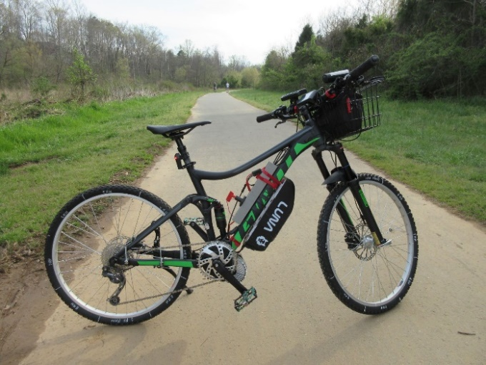  Giant mountain E-Bike with Bafang mid-drive motor and Amerityre airless tires. | 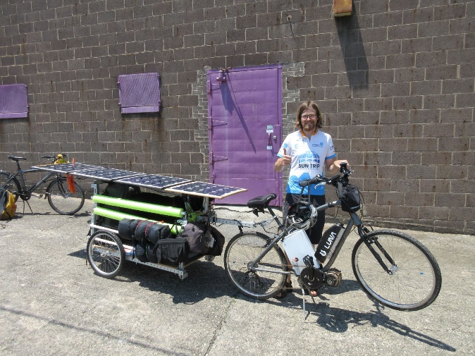  Ryan Gillespie with Sun Drifter E-Bike and solar trailer with Amerityre airless tires.

Both Test E-Bikes are equipped with Cycle Analyst Analogger data acquisition systems. Data is recorded every second. All the data is available in the A1 Data Folder in the ASU TEVA USB drive.
10. Test Facilities
ASU provided test facilities at 3 locations owned by ASU.
- Old Watauga high school athletic facilities purchased by ASU for future expansion
- Private ASU road behind class room lab
- Top floor of parking garage next to class room lab
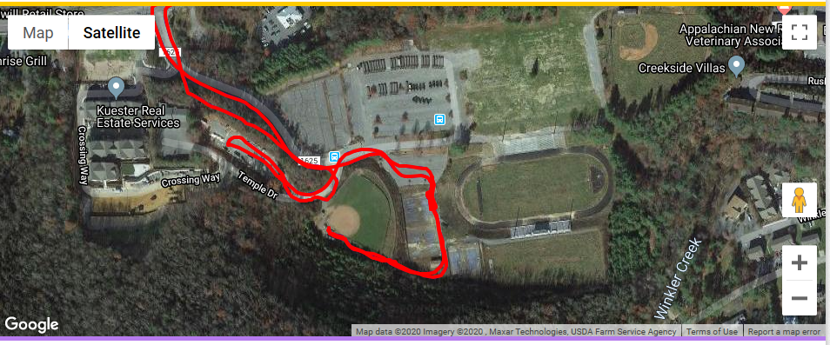
Old Watauga High School track and athletic fields
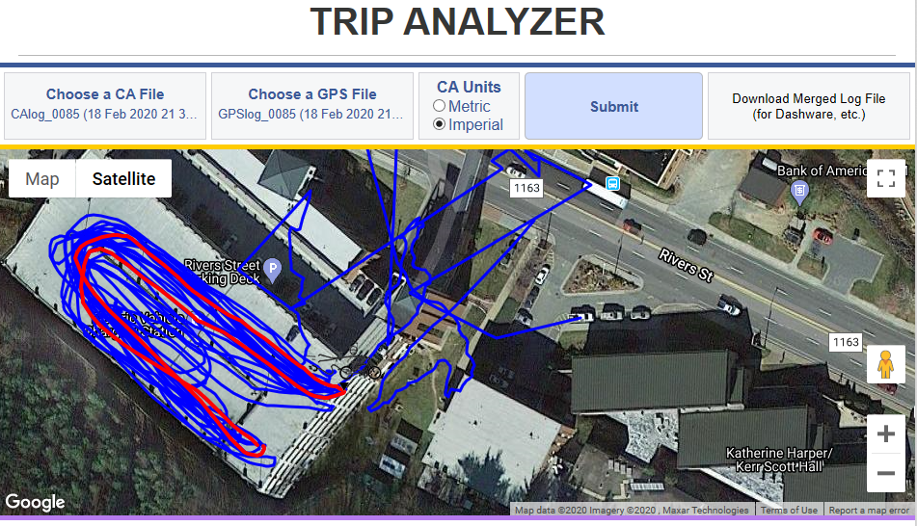
Testing E-Bikes on top of ASU parking garage next to E-Bike class room lab building
The ASU facilities were closed after the first 8 weeks of the spring semester because of the corona virus. EAA TEVA members continued testing at alternative sites and sent the data to the students for analysis.
The following alternative test sites were also used.
- Nanzetta private paved road
- Nanzetta private Mountain bike trail
- Clemmons NC Southwest School track
- Alamance NC Community College
- Shallowford Road Lewisville NC
- Winston-Salem bike path
- Brookberry Farm W-S NC
- Horizons Park Forseyth County NC
- Winston-Salem NC streets
11 Test Types
The students were organized into 6 teams to conduct the following test types. Refer to the “Information and Procedure” Folder in the ASU TEVA USB drive for additional information. Examples of the results are provided below. Refer to the detailed Trip Analyzer Test Reports in the ASU TEVA USB drive for additional information. The student reports are in the “A2 Student Reports Folder” in the ASU TEVA USB drive.

- Rolling Resistance and Energy Usage
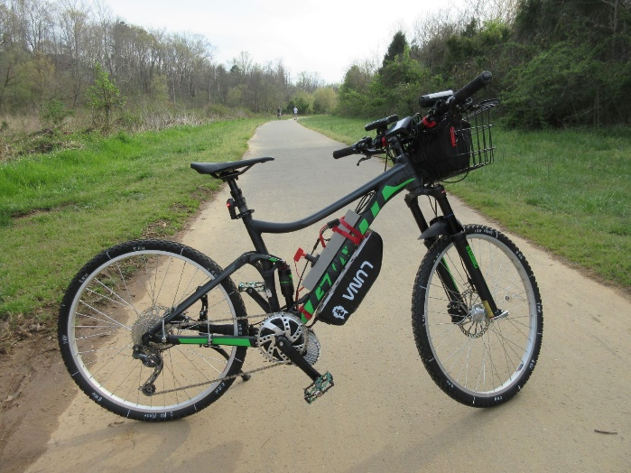
Giant Stance Luna Bafang mountain bike with the Amerityre 26x1.5 airless mountain tread tires

Trip Analyzer Reports Giant #72, 76, 78
Energy was 13.35 wh/mi at 10 mph – Report #72
Energy was 21.40 wh/mi at 15 mph – Report #76
Energy was 25.22 wh/mi at 20 mph – Report #78

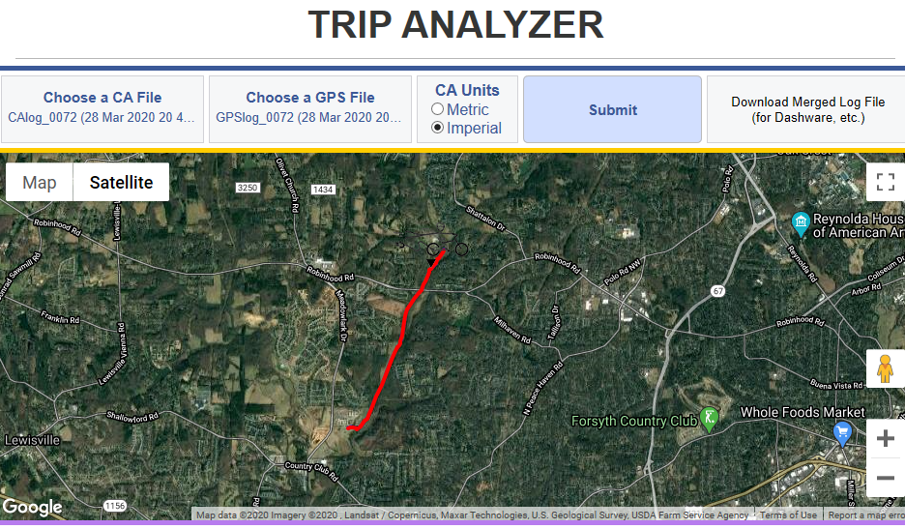

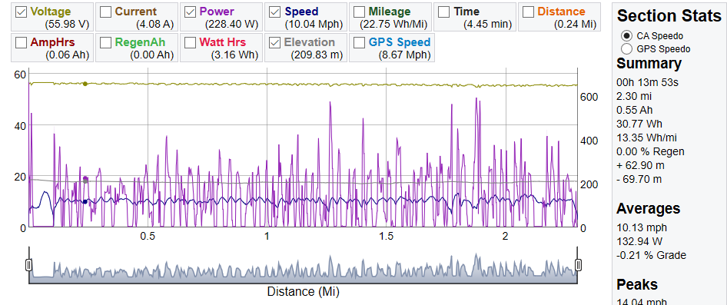

- Tire Handling
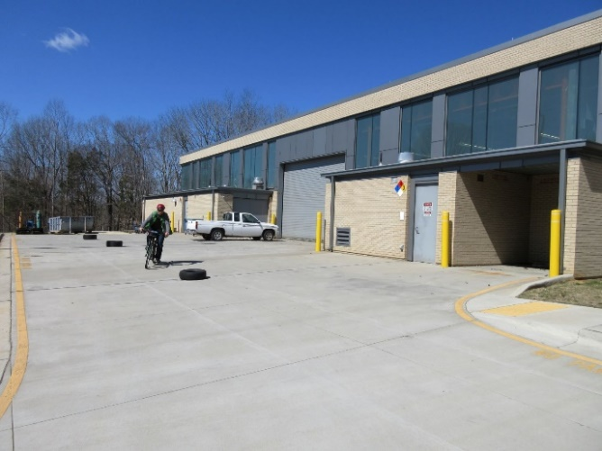  Slalom handling tests around tires. Trip Analyzer Report Giant #40. | 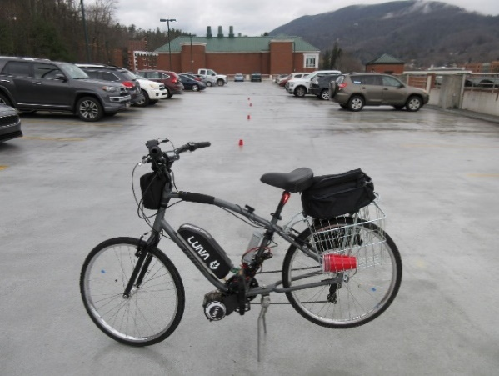  Top 6th floor of ASU Rivers Street parking deck. Sun Drifter E-Bike with Amerityre 26 x 1.95 All Terrain airless tires. Slalom test.  Report Sun #85

- Braking
Test Procedure
Braking tests were conducted at 5, 10, 15 and 20 mph. The E-Bike was accelerated by motor power to above the test braking speed. The start braking location was identified by a start marker board beside the road. The bike was coasted with no power so that the test speed was reached at the start marker board. Front and rear brakes were applied as the front wheel of the bike passed the marker board. The brakes were applied firmly to the point just before brake lockup. There was a slight trace of rubber left on the pavement although the brakes did not skid or lock up. The stopping distances were recorded.

Results for baseline Sunlite air type tires
The hydraulic disk brakes and tires operated fine. The braking was smooth. The brakes have the capability of locking up the wheels. The stopping distances are provided in the following chart.

Speed (MPH) | 5 | 10 | 15 | 20
Stopping distance (Feet) | 1 | 7 | 16 | 38

The results for the airless tires were similar to the air type tires.
- Performance on Various Terrains
Test Procedure – Level Thick Grass
Tests were conducted on the grass level top of the Nanzetta dam. The tests were conducted at 5, 10, 15 and 20 mph. The Giant bike has a Shimano HG 9 speed cassette with sprocket teeth of 11-13-15-17-20-23-26-30-36. For normal riding we use gear position 4 with 23 sprocket teeth. This keeps the chain centered on the sprocket cassette. For the grass terrain tests at 5, 10 and 15 mph we use gear position 2 with 30 sprocket teeth. The lower gear #2 with 30 sprocket teeth allowed the mid drive motor to spin faster and develop more torque at the rear wheel. The maximum speed with gear #2 is about 17 mph. We used gear #4 for the 20 mph test. The special Bafang BBSHD mid-drive test motor can develop 150 NM of torque.

Details
Data Files Giant CAlog 151 and 152.
Refer to WTA-7 (Front) and WTA-8 (Rear) Wheel and Tire Build Documents for additional information on the Amerityre 26x1.5 mountain tread airless tires.

Weather
Temp 68 degrees F, No wind, No rain
6 inch high dry grass

Results
The Giant Stance E-Bike with the Amerityre airless tires worked well. The traction was good. There was little slippage. Approximately 50 wh/mile was used at 5 mph and 100 wh/mile at 20 mph to travel in the thick 6 inch grass. I ranked the tires 7 out of 10 for the straight line test with no turning
Test Procedure – 20 and 30 degree slopes
This report provides the data for climbing the grass slope of the Nanzetta Lake dam with the Giant Stance E-Bike and Amerityre 26x1.5 airless type mountain bike tread tires. The first climb location has a slope of 20 degrees and the second climb has a slope of 30 degrees.
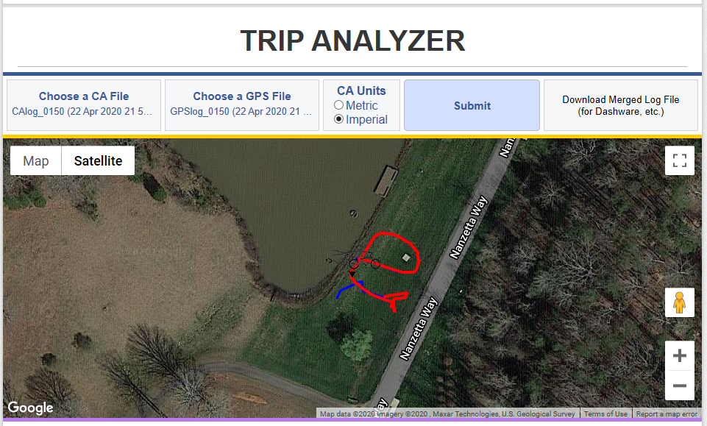
Two locations were selected on the hill slopes for the dam. The first slope is 20 degrees and the second slope is 30 degrees. The Giant bike has a Shimano HG 9 speed cassette with sprocket teeth of 11-13-15-17-20-23-26-30-36. For normal riding we use gear position 4 with 23 sprocket teeth. This keeps the chain centered on the sprocket cassette. For the hill test we use gear position 2 with 30 sprocket teeth. The lower gear #2 allowed the mid drive motor to spin faster and develop more torque at the rear wheel. The special Bafang BBSHD mid-drive motor can develop 150 NM of torque. The rider has to apply the power gently to avoid wheelies with the front wheel lifting off the ground.
The rider was able to approach the bottom of the slope at about 5 mph. Approximately 2400 watts of power was applied to accelerate up the hill at 10 mph.

Details
Data Files Giant CAlog 150.
Refer to WTA-7 (Front) and WTA-8 (Rear) Wheel and Tire Build Documents for additional information on the Amerityre 26x1.5 mountain tread airless tires.

Results
The Giant Stance E-Bike with the Amerityre airless tires worked well. The traction was good. There was little slippage. Approximately 2400 watts of power were used to accelerate up the hill. I ranked the tires 7 out of 10 for the straight line test with no turning.

Discussion
This was a straight line test with the small 26x1.50 Amerityre mountain tread tires. Larger diameter and wider 27.5x2.50 tires would be more appropriate if the bike was turning or the ground was wet.

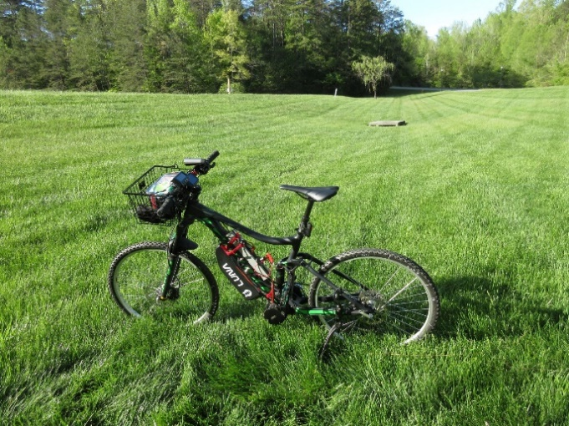  Thick grass by Nanzetta Lake dam | 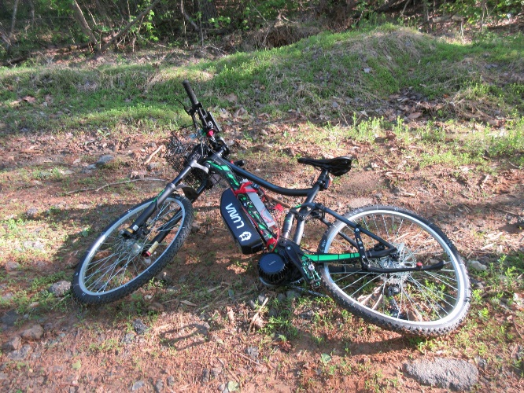  Down bike with failed rear wheel

Test Procedure - Steep Rock Base Mountain Bike Trail
The rear wheel failed while climbing the Nanzetta steep rock base mountain bike trail. Refer to Report Giant 155.

- Ride Comfort
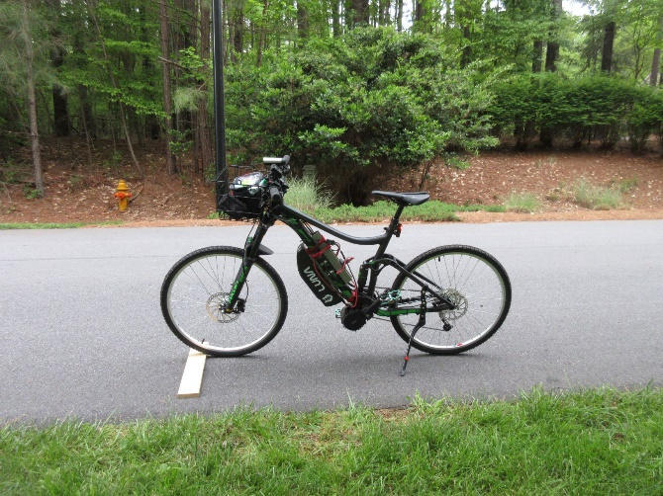  Giant Stance Luna Bafang mountain bike.  .75 inch thick bump board. Reports Giant #167-170, 175-176 | 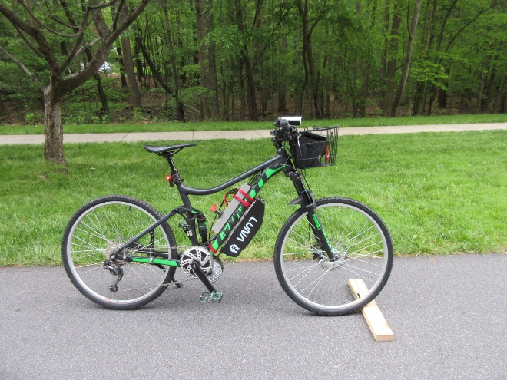  Giant Stance Luna Bafang mountain bike.  1.50 inch thick bump board. Reports Giant # 167-170, 175-176

The ride comfort was good. Refer to the reports for the detailed results.
- Tire Wear
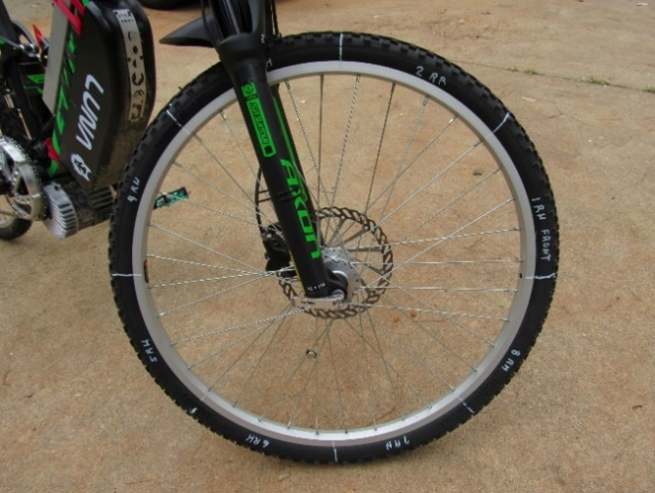  Giant Stance Luna Bafang mountain bike with the Amerityre 26x1.5 airless mountain tread front tire. The tires are marked into 8 sections for tread wear analysis. Refer to Trip Analyzer Report Giant #40. | 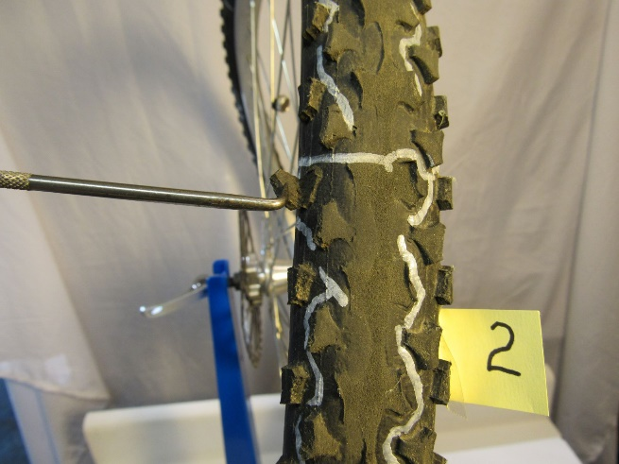  Loose lug at end of probe. Flat spot from brake wear during aggressive brake tests. Amerityre 26x1.5 airless mountain tread rear tire. Photo 5346

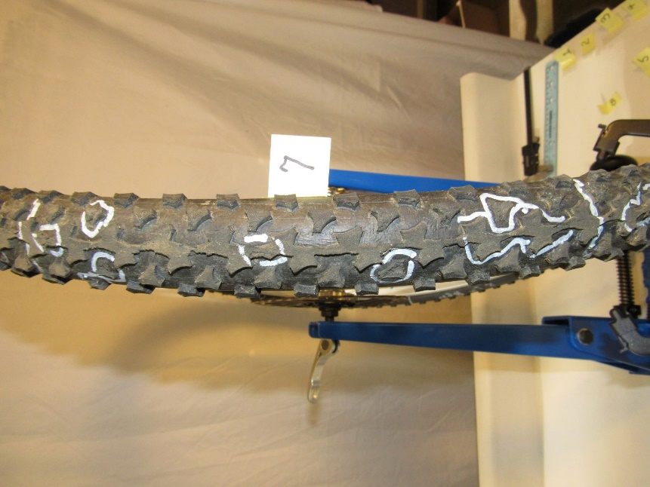  Missing lugs. Photo 5333  Amerityre 26x1.5 airless mountain tread rear tire. The wheel failed during aggressive testing. | 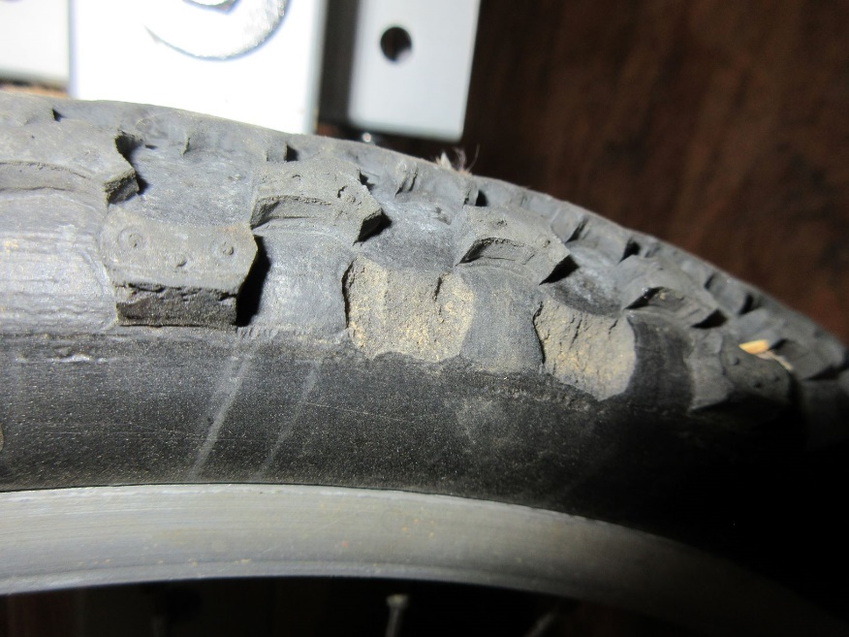  Missing lugs on 20x1.50 trailer tire. Photo 4426.

12 Trailer Test
Ryan Gillespie with Test E-Bike and solar trailer with Amerityre airless tires | 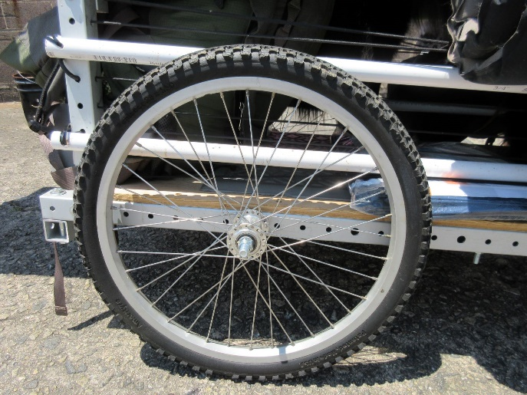  Amerityre trailer 20x1.50 airless tire

Equipment Description
The Test E-Bike is equipped with Amerityre 26x1.95 all terrain tread airless tires. The trailer is equipped with Amerityre 20 x 1.50 mountain tread airless tires. Ryan Gillespie built the solar trailer for the future Sun Race across China in 2012. The Sun E-Bike is equipped with a Cyclone mid drive motor. A Cycle Analyst is used to control the output power of the motor. A CA Analogger data acquisition system is used to collect data approximately every second. The 4 section solar panels provide energy to recharge the battery.
The trailer is constructed from lightweight aluminum. The total weight of the trailer including the solar panel, a 55 lb. dog and camping equipment for 3 people is 235 lbs.
Trip Description
The test trip is a 2 day camping round trip between Winston-Salem NC and East Bend NC. The total distance was 64 miles. The average speed was 14 mph and the maximum speed was 27 mph.
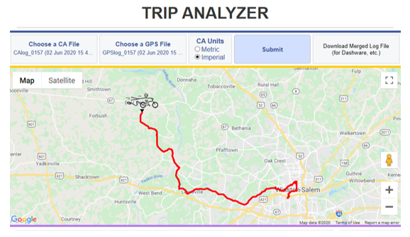
Discussion
Additional information is available in Trip Sun Report #157. The trailer worked fine except some of the tire lugs came off. Refer to photos #4426 and #4437.
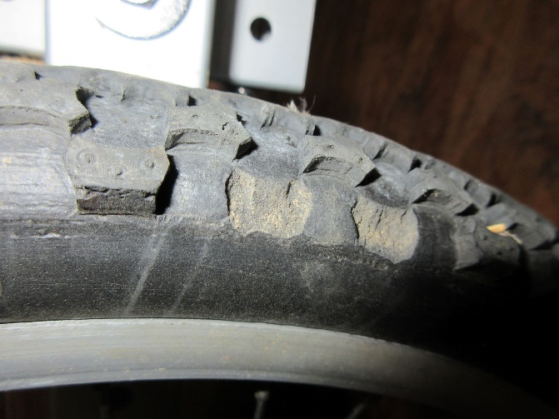  Missing lugs from trailer tire. Photo 4426. | 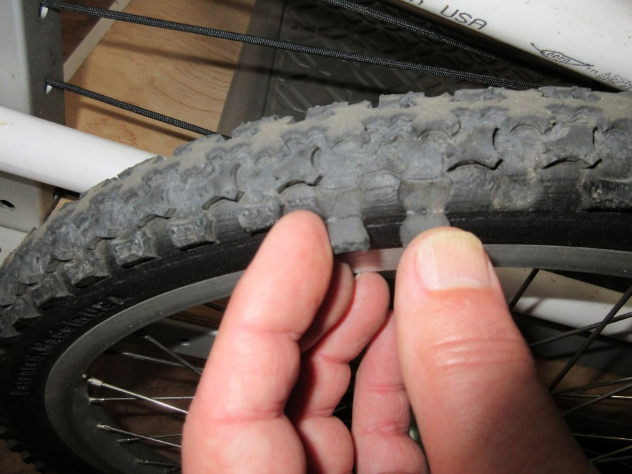  Loose lugs on trailer tire. Photo 4437.

13 Test Data
All of the test data is available on the ASU TEVA USB drive in the Data Folder. Directions on generating Trip Analyzer Reports at www.ebikes.ca are available on the ASU TEVA USB drive in file “TEVA-27 Cycle Analyst Analogger Trip Analyzer” in the “Information and Procedures” folder.
14 Wheels
It was difficult to find wheels for the Amerityre airless tires. The Wheel Master WM 26 559x25 Model Steel 7X rim JBI part #470743 was the best rim fit we found. The 36 spoke steel rim is inexpensive and the Amerityre airless tire was easy to install. The rim did not fail during our tests. Refer to Report GC-2020-1 in the Gerhardt Cycles Reports Folder.
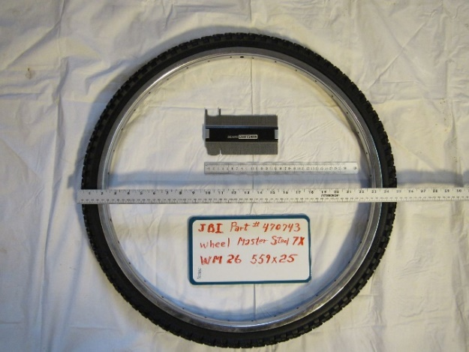  Amerityre 26x1.95 airless tire on WM rim | 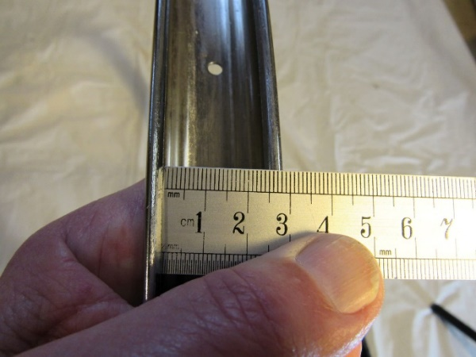  WM 26 559x25 rim width measurement

